// String

public class Example1 {
public static void main(String[] args) {
String s1= "I am from IT department";
String s2 = new String("IInd year");

System.out.println(s1);
System.out.println(s2);
}
}

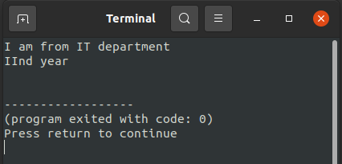
Output:

